Manufacturing/Industrial Center Designation Application Form

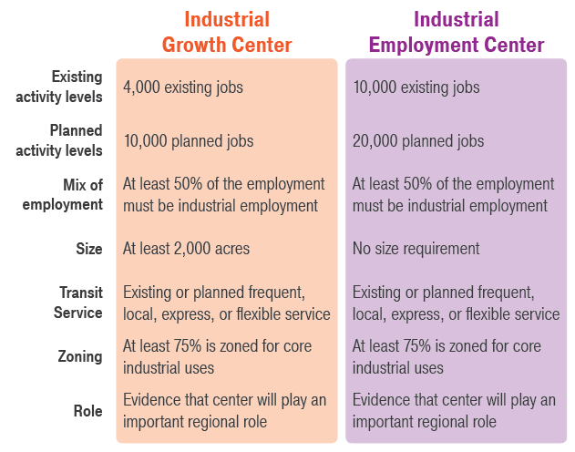
How to Complete this Application
This application is for jurisdictions seeking designation for a Manufacturing Industrial Center designation. There are three sections to this application: (1) Applicant Information; (2) Eligibility; and (3) Designation Criteria. Please respond to the questions as specifically as possible and include attachments and references to local and/or countywide plans, policies, maps, and other information relevant to the questions. As a component of the 2018 Centers Framework Update, there are two types of Manufacturing/Industrial Centers: Industrial Growth Centers and Industrial Employment Centers. Figure 1 describes the requirements for Industrial Growth and Industrial Employment Centers in detail.
Figure 1 - Designation Criteria for Manufacturing/Industrial Centers

Applications should be submitted via email to the staff member listed on PSRC’s centers webpage. Please contact PSRC staff with any questions or assistance with submittal. For more information and resources about PSRC’s centers program, please visit psrc.org/centers. The Designation Procedures for New Centers contains complete information about PSRC’s requirements for designation as a center.

Section 1: Applicant Information
Please include the following information:
Name of proposed center | write here
Type of center | ☐ Industrial Growth Center  ☐ Industrial Employment Center
Name of jurisdiction(s) | write here
Name of primary staff contact(s) | write here
Contact information | Phone(s):  Address(es):  Email(s): | write here  write here  write here
Date of submittal | write here
Briefly describe the center as well as the goals for regional center designation (up to 200 words) | write here

Section 2: Eligibility Criteria
Please address each of the following questions regarding criteria for eligibility.

- Completed Center Plan
The jurisdiction must have completed a center plan (subarea plan, plan element, or functional equivalent) that provides detailed planning or analysis and meets planning requirements in PSRC’s Plan Review Manual prior to applying for MIC designation. Please attach the completed center plan to this application.

- Historical and Planned Investments
The center should be a local priority, and the jurisdiction(s) should have a long-term commitment to making local investments in infrastructure and transportation. Please describe the historical and ongoing planned local investments to create a thriving industrial center and provide any relevant supporting documentation.
write here

- Preserving Industrial Uses
The jurisdiction(s) should have a long-term commitment to protecting and preserving industrial uses in the center, including strategies and incentives to encourage industrial uses and established partnerships to ensure success of the manufacturing industrial center. Please describe commitments and partnerships in place to preserve and encourage industrial uses
write here

- Local Comprehensive Plan Designation
The center should be identified as a candidate for regional manufacturing/industrial center designation in the local jurisdiction’s comprehensive plan. Please describe when the center was identified as a candidate center and provide an attachment with the relevant comprehensive plan sections.
write here

- Request for Center Designation
The jurisdiction has adopted an ordinance or resolution that requests PSRC designate the center as a manufacturing/industrial center and authorizes its staff to submit a completed application. Provide the ordinance or resolution as an attachment to this application.
write here

- Countywide Commitment
The center is identified as a candidate for regional manufacturing/industrial center designation in the applicable countywide planning policies. Please describe when the center was identified in the countywide planning policies and provide a copy of the relevant pages from the countywide policies.
write here

- Environmental Suitability
The center should be located in an area appropriate for industrial development. Please demonstrate that environmental review has been completed and that the area is suitable for development. Discuss any key environmental mitigation strategies specific to the center location. Provide attachments as needed.
write here

- Jurisdiction
Manufacturing/industrial centers are to be located in cities, with few exceptions. Please describe the location of the center. If the center is in the unincorporated urban growth area, please demonstrate the history of, and collaborative agreement, regarding joint planning and service provision, and joint plans for annexation or incorporation. If the center is in an unincorporated area or has multiple jurisdictions named on the application, please describe the manner and structure (e.g. interlocal agreement, memorandum of understanding) with which the jurisdictions will plan together over the long-term.
write here

- Adjacent Land Uses
Please describe the adjacent land uses within ½ mile of the proposed center boundaries and their relationship to the center, including how impacts from industrial uses on these areas are mitigated.
write here

- Existing Conditions
Please address each of the following questions related to the existing conditions of the proposed center. The jurisdiction must demonstrate the following conditions of the proposed center exist at the time of the application:

10a. Existing Infrastructure
Please describe how existing and planned infrastructure and utilities can support additional center growth.
write here

10b. Access to Transportation
Please describe how access to relevant transportation is provided, including freight.
write here

10c. Shape of Center
Please describe the shape of the center and the rationale for the center boundaries.
write here

10d. Economic Impact
Please describe the industrial center’s economic impact.
write here

Section 3: Designation Criteria
Please address the following questions regarding criteria for designation as a manufacturing/industrial center.

- Compatibility with VISION 2040
Describe how the jurisdiction’s vision for the proposed manufacturing/industrial center reinforces the centers concept within VISION 2040.
write here

- Existing Activity
Prior to seeking regional designation, the proposed center must have a minimum existing employment level of:
- Industrial Growth Centers: 4,000 jobs
- Industrial Employment Centers: 10,000 jobs
Please describe the existing number of jobs in the center and highlight major employers or industries in the center.
write here

- Planned Activity
The proposed center must be planning for at least a total of:
- Industrial Growth Centers: 10,000 jobs
- Industrial Employment Centers: 20,000 jobs
Please describe the planned levels of activity in the center and attach a zoning and land use map showing areas of where the planned growth may be accommodated.
write here

- Zoned Development Capacity
Because it is not time-bound, zoned capacity can allow levels of development that are higher than the activity unit target. This allows a jurisdiction to support long-term higher levels of density that achieves the regional vision for a more compact, complete and mature urban form in regional centers. Please demonstrate that the center has sufficient zoned development capacity to adequately accommodate targeted levels of growth.
write here

- Employment Type
At least 50% of the employment in manufacturing/industrial centers must be industrial employment. Please describe the existing mix of employment.
write here

- Size and Shape
Manufacturing/Industrial Centers must meet the following size requirements:
- Industrial Growth Centers: 2,000 acres
- Industrial Employment Centers: No size requirement
Please describe the shape of the center, the rationale for the center boundaries, and the size of the proposed center.
write here

- Transit
If the center is within a transit service district, it must have existing or planned frequent, local, express, or flexible transit service. If the center is outside a transit service district, documented strategies to reduce commute impacts through transportation demand management (TDM) strategies must be in place and consistent with the Regional Transportation Plan’s Regional TDM Action Plan. Please describe the transit service for the proposed center, which may include information such as the existing and planned service, number of stops, and frequency of service.
write here

- Zoning
Proposed centers must have at least 75% of the land area zoned for core industrial uses, such as manufacturing, transportation, warehousing, and freight terminals. Commercial uses within core industrial zones shall be strictly limited, and strategies to retain industrial uses must be in place. Please describe the zoning for the proposed center and how the zoning designations will protect industrial land from incompatible uses.
write here

- Role of Center
Centers are expected to play a key regional role in accommodating significant industrial employment growth and preserving industrial land. Please describe the role the center currently plays and the anticipated future role.
write here

- Attachments
Please list all documents attached to this application below.
write here

- Additional Information
Please provide any additional information you would like PSRC to consider during the application and review process.
write here

Planned activity growth targets are the amount of growth a jurisdiction has agreed, through the countywide process, to plan for throughout its comprehensive plan elements over the 20-year horizon of the comprehensive plan. The targets include both the baseline density (current) plus the 20-year growth.
Zoned Development Capacity is the amount of development allowed under adopted zoning based on parameters in the zoning regulations such as allowed heights and densities, lot coverages and setbacks, floor area ratios, etc. Zoned Development Capacity is not bound to a specific planning horizon. Jurisdictions must have adequate zoned capacity to accommodate their Growth Target, and this is evaluated under Buildable Lands.

