Regional Growth Center Application Form

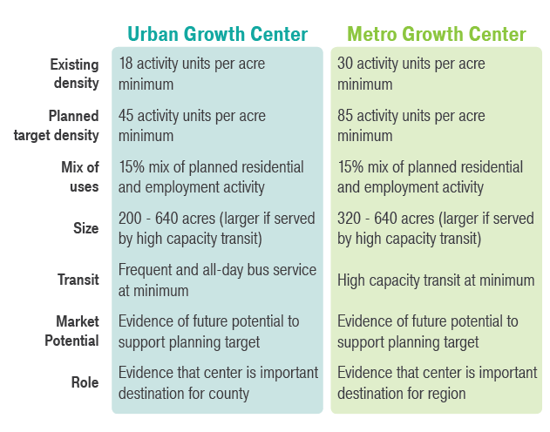
How to Complete this Application
This application is for jurisdictions seeking designation of a new regional growth center. There are three sections to this application: (1) Applicant Information; (2) Eligibility; and (3) Designation Criteria. Please respond to the questions as specifically as possible and include attachments and references to local and/or countywide plans, policies, maps, and other information relevant to the questions. As a component of the 2018 Centers Framework Update, there are two types of regional growth centers: Urban Growth Centers and Metro Growth Centers. Figure 1 describes the requirements for both types in detail.
Figure 1 - Designation Criteria for Regional Growth Centers

Applications should be submitted via email to the staff member listed on PSRC’s centers webpage. Please contact PSRC staff with any questions or assistance with submittal. For more information and resources about PSRC’s centers program, please visit psrc.org/centers. The Designation Procedures for New Centers documents PSRC’s requirements and process for designating new centers.

Section 1: Applicant Information
Please include the following information:
Name of proposed center | write here
Type of Center | ☐ Urban Growth Center  ☐ Metro Growth Center
Name of jurisdiction | write here
Name of primary staff contact(s) | write here
Contact information | Phone:  Email:  Address | write here  write here  write here
Date of submittal | write here
Briefly describe the center and goals for designation as a regional center  (up to 200 words) | write here

Section 2: Eligibility Criteria
Please address each of the following questions regarding criteria for eligibility.

- Completed Center Plan
The jurisdiction must have completed a center plan (subarea plan, plan element, or functional equivalent) that provides detailed planning or analysis that meets planning requirements in PSRC’s Plan Review Manual prior to applying for regional growth center designation. Please attach the completed center plan to this application.

- Historical and Planned Investments
The center should be a local priority, and the jurisdiction should have a long-term commitment to making local investments to create a walkable, livable center. Please describe historical and planned local investments to create a walkable, livable center. Provide any relevant supporting documentation in an attachment.
write here

- Local Comprehensive Plan Designation
The center should be identified as a candidate for regional growth center designation in the local jurisdiction’s comprehensive plan. Please describe when the center was identified as a candidate center and provide a copy of the relevant comprehensive plan sections.
write here

- Request for Center Designation
The jurisdiction must adopt an ordinance or resolution that requests PSRC designate the center as a regional growth center and authorizes its staff to submit a completed application. Cite the number and date of the ordinance or resolution and provide as an attachment.
write here

- Countywide Commitment
The center should be identified as a candidate for a regional growth center designation in the applicable countywide planning policies. Please describe when the center was identified in the countywide planning policies and provide a copy of the relevant pages from the countywide policies.
write here

- Environmental Suitability
The center should be located in an area appropriate for dense development. Please demonstrate that environmental review has been completed and that the area is suitable for dense development. Discuss any key environmental mitigation strategies specific to the center location. Provide attachments as needed.
write here
- Jurisdiction
Centers are to be located in cities, with few exceptions. Link Light Rail stations in unincorporated areas may be eligible for regional designation, provided they are affiliated for annexation or planned for incorporation. Please describe the location of the center. If the center is in the unincorporated urban growth area, please demonstrate the history and collaborative agreement for joint planning and service provision, in addition to joint plans for annexation or incorporation.
write here

- Existing Conditions
Please address each of the following questions on existing conditions of the proposed center. The jurisdiction must demonstrate the following conditions of the proposed center exist at the time of the application:

8a. Mix of housing and employment

Please describe the mix of housing and employment currently in the center.
write here

8b. Existing Infrastructure
Please describe how existing and planned infrastructure and utilities can support additional center growth.
write here

8c. Walkability
Please describe the bicycle and pedestrian infrastructure, nonmotorized amenities, and street pattern in the center, and how these investments support walkability and nonmotorized access.
write here

Section 3: Designation Criteria
Please address the following questions regarding criteria for designation as a regional growth center.

- Compatibility with VISION 2040
Describe how the jurisdiction’s vision for the proposed regional growth center reinforces the centers concept within the VISION 2040 regional growth strategy and multicounty planning policies.
write here

- Size and Shape
The center should be walkable and able to be served by transit. In this section, please describe the size and shape of the center, and how it helps provide a walkable environment and easy connections to transit.
i. Regional Growth Centers must meet the following size requirements:
- Urban Growth Centers 200 to 640 acres, or larger with internal, high capacity transit system
- Metro Growth Centers: 320 to 640 acres, or larger with internal, high capacity transit system
Please identify the size of the proposed Regional Growth Center.
write here

ii. Centers should be generally round or square in shape and avoid linear or gerrymandered shapes that are not readily walkable or connected by transit. Please describe the rationale for the proposed center boundaries, particularly any deviations from guidelines on center shape.
write here

- Existing Activity Levels
Prior to seeking regional designation, the proposed center must have a minimum existing activity level of:
- Urban Growth Centers: 18 activity units per gross acre
- Metro Growth Centers: 30 activity units per gross acre
Please describe the existing levels of activity in the center and provide a map of existing land use.
write here

- Planned Activity Levels

The proposed center must have a minimum target activity level of:
- Urban Growth Centers: 45 activity units per gross acre
- Metro Growth Centers: 85 activity units per gross acre
Please describe the planned levels of activity in the center and attach a map of planned land use showing areas of where planned growth may be accommodated.
write here

- Mix of Housing and Employment
Regional centers should have a goal in place for a balanced mix of uses in center. The total mix of activity units in the center should consist of a minimum of 15% each of population and employment. Please describe how the proposed center addresses this goal for a mix of housing and employment and attach any relevant pages of the comprehensive plan.
write here

- Zoned Development Capacity
Because it is not time-bound, zoned capacity can allow levels of development that are higher than the activity unit target. This allows a jurisdiction to support long-term higher levels of density that achieves the regional vision for a more compact, complete and mature urban form in regional centers. Please demonstrate that the center has sufficient zoned development capacity to adequately accommodate targeted levels of growth.
write here

- Long-Term Growth
Regional growth centers are expected to achieve densities sufficient to support high-capacity transit through long-term growth and development over the 20-year comprehensive planning period and beyond. Describe any tools or strategies that support a long-term vision and help avoid short-term lower density and potentially inappropriate types of development.
write here

- Adjacent Land Uses
Please describe the adjacent land uses within ½ mile of the proposed center boundaries and their relationship to the center, including multimodal connections to and between the center and adjacent neighborhoods and districts.
write here

- Transit
The proposed center serves as a major transit hub and has high quality, high capacity existing or planned service. This includes having existing or planned light rail, commuter rail, ferry, or other high capacity transit with similar frequent service as light rail. Frequent all-day service is defined as:
- Urban Growth Centers: 16 service hours per weekday and headways at 15 minutes or less
- Metro Growth Centers: 18 service hours per weekday and headways at 15 minutes or less
Please describe the transit service for the proposed center, including the existing and planned service, the headways, and number of service hours per weekday.
write here

- Market Potential
Proposed centers must have evidence that there is market potential to support the planning target identified. Please describe the market potential for the proposed center and discuss and cite supporting studies or information available. If a market study has been completed, please include as an attachment.
write here

- Role of Center
Centers are expected to serve as a destination for people across the region, with services and amenities like major employers and institutions, civic functions, entertainment and cultural attractions, and regional transportation connections. The role of the center includes the number of people that can access the center, are served by the center, and access to regional transportation facilities and services. Urban and Metro Growth centers must:
- Urban Growth Centers: Serve as an important destination for the county.
- Metro Growth Centers: Serve as an important destination for the region.
Please describe the role the center currently plays and the anticipated future role.
write here

- Attachments
Please list all documents attached to this application.
write here

- Additional Information
Please provide any additional information you would like PSRC to consider during the application and review process.
write here

Activity units are the combination of population and employment in the center. Activity unit density is calculated based on the gross acres in the center. PSRC can provide assistance with calculating activity units for the proposed center.
Growth Targets are the amount of growth a jurisdiction has agreed, through the countywide process, to plan for throughout its comprehensive plan elements over the 20-year horizon of the comprehensive plan. The targets include both the baseline density (current) plus the 20-year growth. PSRC has a guidance paper on center growth targets which may be a useful resource.
Zoned development capacity is the amount of development allowed under adopted zoning based on parameters in the zoning regulations such as allowed heights and densities, lot coverages and setbacks, floor area ratios, etc. Zoned development capacity is not bound to a specific planning horizon. Jurisdictions must have adequate zoned capacity to accommodate their growth target.

